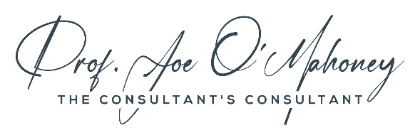

Governance Check-List

The list below is a checklist for governance for a professional service firm for a maturing firm (100+ employees). Your governance should match both the maturity of your firm and your strategy and should be reviewed annually.
The CEO is ultimately responsible responsible for good governance of the firm on behalf of its owners and stakeholders, and ensuring this aligns with the strategy (i.e. creating the governance for the future organisation). However, the CEO will often delegate accountability and responsibility to the board of directors.
Governance documents | Governance structure (boards, trustees, advisors, NEDs);  Legal incorporation documents: e.g. Certificate of incorporation; Articles of association;  Partnership agreement;  Key policies (whistle-blower; diversity; data etc.);  Governance review policy;  Conflict resolution and arbitration policy.
Strategy & Plan | Vision;  Mission;  Strategy;  Targets  Plan, actions & responsibilities;  Budgets;
Organisational Structure | Organisational hierarchy;  Roles;  Decision-making (esp. budget)  Delegation & reporting;
Roles | Budget;  Responsibilities;  Authority; targets;  Budgets;  Team;  Inputs;  Outputs;  Internal customers;  Stakeholders;
Meetings | Legal requirements;  Standing meetings;  Ad-hoc meeting triggers;  Escalation & cadance;  Timings & templates.
Risk management | Risk register;  Risk processes;  Mitigation plans;  Escalation process;
Culture & values | Consistency of the above with values and culture;  Cultural leadership;  Culture events (e.g. celebrations; traditions; rituals)

